Line Follower Robot Project (with ROS)

Architecture:

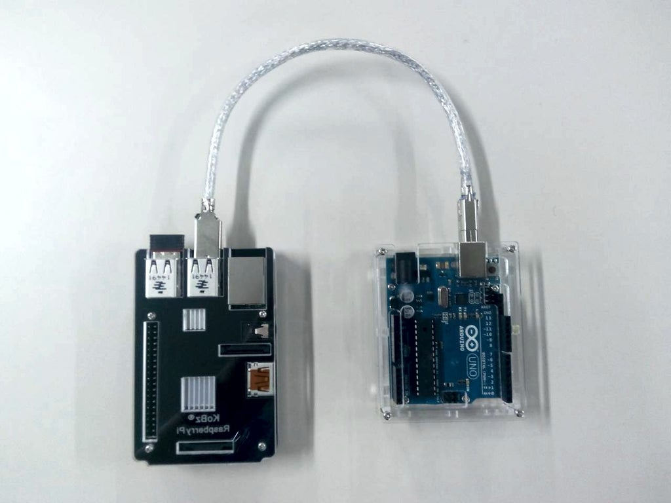

ROS Architecture:

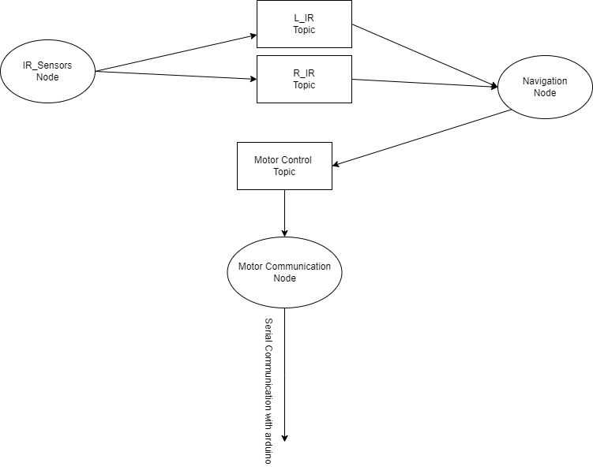

Steps of creating Ros Application:

1- create workspace

2- create line follower package

3- create the three nodes as three scripts

4- communication with Arduino done via python library called serial ([Raspberry Pi - Arduino Serial Communication : 4 Steps - Instructables](https://www.instructables.com/Raspberry-Pi-Arduino-Serial-Communication/))

Useful links:

1- connecting dc motors with Arduino ([In-Depth: Interface L298N DC Motor Driver Module with Arduino (lastminuteengineers.com)](https://lastminuteengineers.com/l298n-dc-stepper-driver-arduino-tutorial/))

2- connecting IR with Rassbperry pi ([How to interface the infrared (IR) sensor to Raspberry Pi 4 (linuxhint.com)](https://linuxhint.com/interface-infrared-ir-sensor-raspberry-pi/))